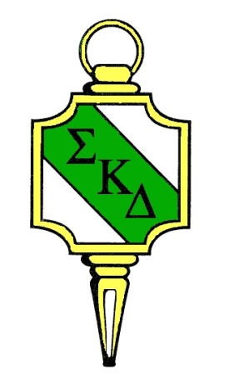
The English Honor Society

Sigma Kappa Delta

Permanent Membership Records
Retain one copy. Send one copy with initiation fees to:
Sigma Kappa Delta National Headquarters
Calhoun Community College
P.O. Box 2216
Decatur, AL 35609-2216.
Please remember: (1) The national fee is $30 per person; (2) List names exactly as they should appear on membership certificates; (3) Check spelling to prevent errors.
Please type all information.
School Name |  | Chapter Name
School Mailing Address

*Advisor Name | Telephone # |  | E-Mail
*Advisor Name | Telephone # |  | E-Mail
*Advisor Name | Telephone # |  | E-Mail
Certificate Date requested:  (if no specific date is requested, the National Office will date the certificate on the day the order is processed) |  | Amount Enclosed:
*If there are additional advisors, please list them.

Allow three weeks for processing.
PAYMENT BY CHECK: Full payment in one check must accompany form. If payment is made with more than one personal check, materials may be held an extra 10 to 15 business days until all checks have cleared.
PAYMENT BY CREDIT CARD: Credit Card payments will have a 4% convenience fee added to the total. For credit card payments by phone, call 256-306-2524 for processing and email the membership form to skd@calhoun.edu. For your safety, credit card information will not be accepted electronically.

For National Office Use only:

Amount Enclosed | Date Processed | Date Verified | Date Mailed

School Name | Chapter Name
# | Full Name (exactly as it is to appear on the certificate) | Student ID Number | Student Email address | NEHS Member? Y/N | NEHS State* | NEHS High School Name*

1
2
3
4
5
6
7
8
9
10
11
12
13
14
15
16
17
18
19
20

*If the student was not a member of National English Honor Society for High Schools (NEHS), please leave the boxes blank.
NOTE: Please ensure all information is entered exactly as it needs to appear on the certificate. There may be a fee for replacement certificates.

